Tiny Fossils, Big Picture
Activity Instructional Guide

MATERIALS AND SET UP

Materials
- Easel with Empty Reconstruction on one side and Fossil Pollen Slide on other side
- Pollen Reference Key Board
- Timeline of Reconstructions Board
- Fossil pollen slide laminated separately
- Hell Creek Today (11x17) and Completed Reconstruction (11 x 17)
- Reconstruction cards through time - Cretaceous, post K-Pg, Cypress Swamp, Today
- Question mark and asteroid cards
- Number tokens 1-8

Set Up

Place easel on the cart or table. Place the Pollen Reference Key in front of the side with the empty reconstruction. Place the number tokens and two copies of each plant on the corresponding plants on the Key (a). Have the 11 x 17 image of Hell Creek today ready to show and quickly put away (b).
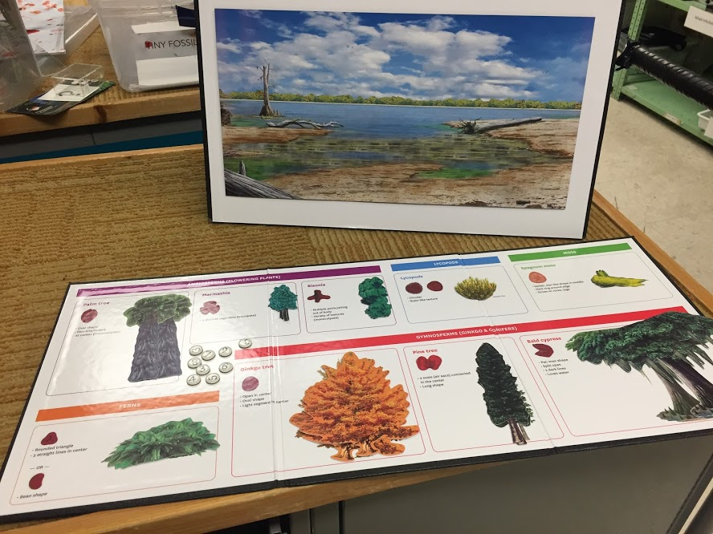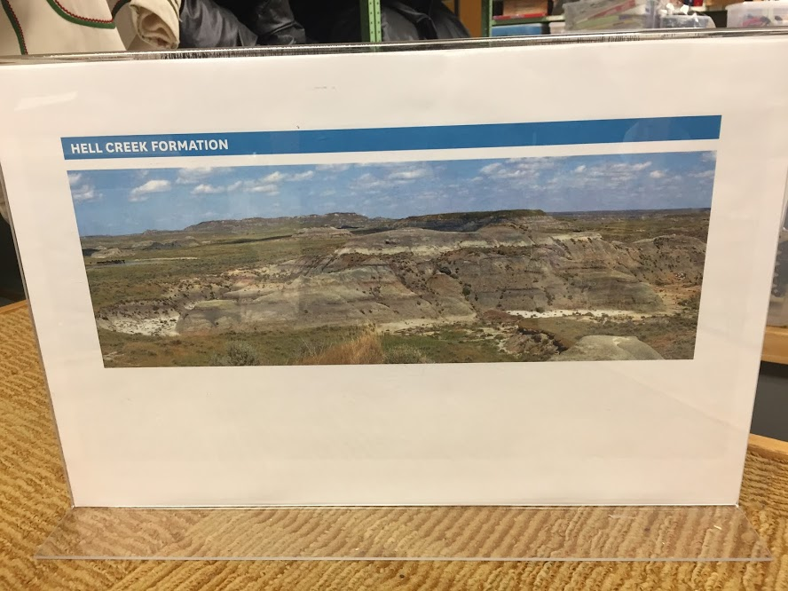
(a) (b)

Have timeline and event cards put away.

Tiny Fossils, Big Picture Activity Overview
Activity Goal | Visitors learn how to use microscopic fossil pollen--evidence of past plant life--to reconstruct a plant community that thrived millions of years ago.
Activity Summary | Visitors work together to help solve a mystery: What did the Hell Creek landscape look like during the time of the dinosaurs? Visitors are assigned roles of paleoartists and field scientists. The field scientists describe the fossil pollen they see in a microscope slide. The paleoartists match the description to a key of plants we know from modern pollen. Each time they identify a plant, they place it in the reconstructed landscape for the Cretaceous. Once they have completed the picture based on the evidence at hand, they are presented with reconstructions of other time periods for that same location. They observe what has changed, make hypotheses about the causes of those changes, and ask questions.
Learning Objectives (what visitors think, feel and do during the activity) | Visitors will  -Understand that pollen is part of a plant and fossilizes, which means it can be used as evidence of the presence of plants in a past ecosystem  -Understand that fossil evidence is laid down in layers, allowing you to compare evidence from one layer, or time period, with evidence from another layer, or time period, and infer change over time  -Describe what they see, drawing on close observation, use of strong descriptive language, and comparison of features, patterns and detail  -Compare the reconstructed ecosystems of the same location at different times and discuss and hypothesize why those changes occurred.  -Feel like they’re doing science
Learning Outcomes (new understandings or changes in perspective that result from activity) | We anticipate visitors who participate in this activity are more likely to:  -Understand that paleontologists use modern examples--including pollen--to extrapolate from evidence they find in the past.  -Understand that paleontologists use different kinds of evidence to compare ecosystems and infer changes in climate over time.  -Look at modern ecosystems and think more critically about what they may have looked like in the past and will look like in the future  -Value the role of artists in science  -Feel more comfortable and confident engaging with science, independently and as a group or family.
Target Audience | Families with children 8-12, but adaptable for all.

Tiny Fossils, Big Picture Activity Flow

What you say | What you do
HOOK:  Would you like to help me piece together a picture of the past?  [INSERT YOUR OWN HERE] | Differentiate according to audience
INTRODUCTION:  Here’s a picture from North Dakota that shows a geologic formation called Hell Creek. This formation stretches through Wyoming, Montana, North Dakota, and South Dakota. This is what it looks like today.  How would you describe the environment?  Do you think it always looked like this? How could we find out?  [acknowledge response]  Well, there is another way. It turns out some paleontologists have found out they can use fossilized pollen to figure out what plants lived in an area millions of years ago!  Do you know what paleontologists do? Have you ever seen pollen before? Where does it come from?  Today, you are going to be paleontologists, and you will use fossil pollen to create a picture of what this landscape looked like many millions of years ago. | Depending on answers, define paleontologist and pollen.
Guided Participation  Part 1  To do science properly requires teamwork, right? So we are going to divide you up to do two different jobs. One group will be the field paleontologists, who describe the pollen that they found in the field. The other group is the paleoartists, who will use the pollen key to identify the plants and populate the picture of the past.  Paleontologist(s) get this blown up microscope slide with fossil pollen collected from North Dakota. You will make observations, and verbally describe the shapes and patterns that you see to your partner(s).  Palynologist(s)/paleoartists. You will look at the key and identify what plant the pollen comes from, based on the description, and place the corresponding plant onto the empty landscape.  [Groups work together]  This is wonderful, you recreated the landscape from 66 million years ago. Let’s show your colleagues what you found.  Would you like to see what a paleoartist and scientist came up with for this time? | Tips for guiding the action:  For younger or less confident visitors: Use the laminated slide and have them work with their adults looking together at the slide and key at the same time.  For all others:  Encourage the use of analogies, comparisons to items in everyday life.  Not all the pollen on the key will be described, including lycopods and bisonia.  Encourage those with the key to ask questions to the partners using the descriptive/science language on the key as well as their own.  If they seem to be getting tired of their roles, have them switch roles half way through.  They might need a little help with the last one. It’s a challenge, because it is a broken example of the fern pollen they already identified.  Here’s the answer key:  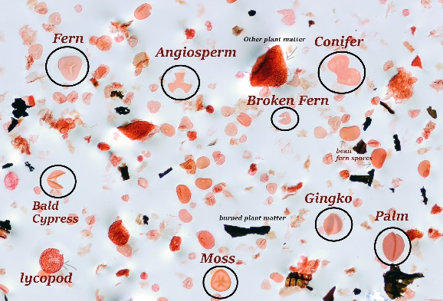  If they want to keep track of which ones they identified, they can user the numbered markers.  Once the two groups have worked through the reconstruction, the paleontologists look at the results. Then show them the full reconstruction that the scientists and illustrators have created.
GUIDED PARTICIPATION - Part 2  It’s truly amazing what a full picture you can get from pollen. And because we can date different layers, we can look at the fossil pollen evidence from the period following this one and see how things changed from that moment 66 million years ago to today.  For example, here’s a picture based on fossil pollen from 1000 years after the picture you made. What do you notice?  What do you think may have happened?  Scientists believe that a meteorite hit the earth just above Mexico, setting off a series of events that led to a mass extinction that killed off most of the species on the planet.  These fern spikes have been attributed to the asteroid impact resulting in the destruction of a majority of plant life. Ferns can thrive and rapidly reproduce, even in barren landscapes such as those left in the wake of the asteroid.  Another 10,000 years later, we see this. And then again, we have this today. How would you describe the changes in the environment from here to here?  What do you think the future holds? | Bring out the timeline and the other reconstructions of the landscape through time.  [Place the tropical ecosystem and the fern spike]  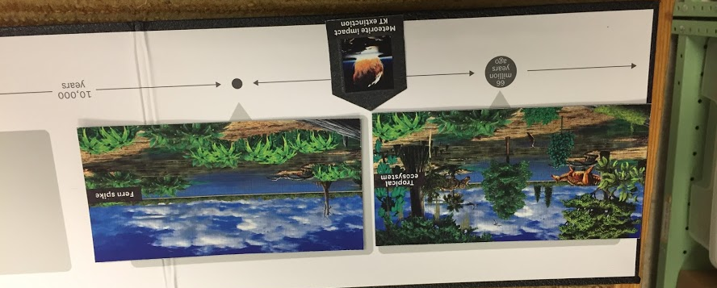  [Add the K-Pg extinction card]  [Place the Cypress Swamp and the photo we started with, and the question mark]  Follow where the conversation goes.  The warm planet led to the reemergence of cypress swamps similar to what was around before the extinction. Eventually a cooler earth led to a dryer, cooler climate in Hell Creek, with less vegetation.  Some scientists believe the future holds greater homogenization, where ecosystems everywhere start to look more similar and have fewer types of plants and animals, due to humans spreading some species (like crops) and killing off others.
WRAP UP/RELEASE:  You did great! Just like scientists and paleoartists you reconstructed the environment during the time of the dinosaurs! You created a whole environment just by looking at microscopic pollen in the dirt. Scientists are interested in fossil pollen because they can use this microscopic world to understand an entire ecosystem and how it has changed over time.  Understanding how plants have responded to climate change events and disasters in the past helps us understand their responses to present day climate change.  Any questions? [Decide if you have time or if it’s time to give a new group a chance]  [INSERT YOUR OWN HERE] | Identify the science skills the visitor used and encourage them to use the same skills when they’re out in nature.  Make connections to science or scientists at the museum.  Make sure to visit . . .  Look closer at reconstructions of past environments . . .  Direct them to other parts of the Museum for related content.

Background Information

Have you ever taken a moment to really look at a paleoartist’s depiction of the environments of the past? If you do, you’ll come to see that rarely are you just shown a depiction of a dinosaur roaring against an empty backdrop. Instead, you’ll likely note the variety of foliage spread across the landscape, perhaps even some insects, lizards, or even small mammals scuttling through the grass. These environmental details may not be the focal point of the piece, but they require just as much research. This is because the plant life that existed in the past was very different from what we are used to seeing today, and paleoartists make sure to take this into account when creating their artistic renderings. But how do paleoartists know what type of plants were found in the ecosystems of long ago? For that, we turn to palynologists.

A palynologist is a person that studies pollen (and other microscopic particles), and paleopalynologists use their knowledge of pollen to attempt to reconstruct what ancient ecosystems may have looked like, based on fossil pollen discoveries.

Pollen may be considered a nuisance to those of us with allergies, but it is a vital component of a thriving ecosystem. Pollen grains are used to transfer the sperm cell producing gametophytes of plants to a compatible female in order to reproduce. To protect the gametophytes during this process, the pollen spores have a hard outer coating called sporopollenin. Beyond aiding the plant in ensuring that the gametophytes are safe in transport, sporopollenin is incredibly useful for paleopalynologists as well because it makes the pollen sturdy enough to fossilize.

Plants produce large quantities of pollen that become widely dispersed by wind, water, or even animals. Because pollen is so common and can cover such a broad range, it is ideal for dating rock formations as we can see the frequent appearance and disappearance of different types of pollen throughout the fossil record, which makes pollen useful as an index fossil. Fossil pollen can also give us impressive amounts of information about past environments and ecologies if we are able to identify what type of plant the pollen came from. Usually fossil pollen is found entirely isolated from its plant of origin, but by comparing pollen in the fossil record to pollen from today’s plants, we can try to match up similar looking forms and infer what kind of plant may have produced it! We can then use this information to see what types of plant life existed at different points in Earth’s history. This all contributes to our big picture understanding of how life on Earth has shifted through time.

One of the major events in Earth’s history that we are all familiar with is the Cretaceous-Paleogene (K-Pg or K-T) mass extinction event that ended the reign of the dinosaurs. At the K-Pg boundary, paleopalynologists have recorded abrupt shifts in terrestrial plant life all over the world, providing additional evidence that this mass extinction was caused by a sudden, catastrophic event such as the asteroid impact that occurred at the Yucatán Peninsula during this time. During the late Cretaceous, flowering plants (angiosperms) were proliferating. North America was covered by warm, flourishing evergreen forests featuring a wide diversity of angiosperm species. At the K-Pg boundary, we see a distinct change in the flora based on a sudden drop in pollen counts for several angiosperm groups, and even the outright disappearance of many others.

In sediment samples collected from immediately after the K-Pg extinction event, paleopalynologists find surprisingly high quantities of fern spores with two distinct spikes of individual fern species. These fern spikes have been attributed to the asteroid impact resulting in the destruction of a majority of plant life. Ferns, however, are able to thrive and rapidly reproduce, even in barren landscapes such as those left in the wake of the asteroid. This rapid shift from a high abundance of angiosperm pollen in the Cretaceous fossil record to a significant absence of angiosperm pollen and an abrupt rise of fern spores after the K-Pg boundary indicates to paleopalynologists that plant life, just like animal life, underwent a dramatic change..

Thousands of years later, the planet was still warm, and Hell Creek would have experienced a reemergence of cypress swamps similar to what was around before the extinction, but with different animals. Eventually, millions of years later, a cooler earth led to the dryer, cooler environment with sparse vegetation that we see in Hell Creek today.

FAQs

What is Palynology?
Palynology is the study of microscopic remains produced by plants and algae, including pollen grains and spores.

How big are pollen grains and spores?
Pollen grains and spores are some of the smallest fossils you can study. If you could stack three pollen grains, the stack would be as thick as a sheet of paper.

Why are the pollen grains different colors?
Pollen grains and spores are naturally yellow, orange, or brownish and can be almost transparent when viewed under a microscope. To better see them, a dye is used to artificially color them.

Where do you find fossil pollen?
Plants disperse pollen grains and spores for reproduction. They are transported by wind, water and insects, and can get deposited in sediments where they will fossilize. Sedimentary rock samples are dissolved in the laboratory using very strong acids, leaving the organic matter intact, including pollen and spores, algae, fungi, wood fragments and leaf cuticles. A chunk of rock the size of a die can easily contain a million spores and pollen grains!

What can we learn from fossil pollen?
Several species of plants became extinct at the end of the Cretaceous, just like the non-avian dinosaurs. By looking at the pollen record, we can pinpoint when and where different genera went extinct or recolonized. Pollen and spores can be traced back to the parent plant that produced them, and can be used to reconstruct an image of the vegetation that once flourished in a given location.

How do scientists know what plants relate to the fossil pollen types?
We can compare fossilized pollen found in the field to modern pollen grains from different genera of plants. Since the structures have not changed dramatically within a given family, we can make an educated guess about which types of plants (conifers, angiosperms, ferns, etc) used to occupy a given location. We can also collect evidence based on other plant fossils, such as leaf imprints, that we find in the area to reconstruct an image of what the plant used to look like.

Can you tell how many individual plants were in an area based on the number of pollen grains?
Multiple pollen grains can come from a single plant, so you can not get an exact estimate, but you can learn something about the relative abundance of plants in a given area based on how many of each kind of pollen morph you find.

How much time is encompassed in one centimeter of sediment?
It depends on the rate of input of material into the depositional basin, influenced by tectonics, erosion rate, and type of sediment being transported. In some areas, the land’s history could involve a lot of tectonic activity that folded and pressed sedimentary layers together. Compression varies depending on where you look, so there’s no universal way to determine how much time passed based on the thickness of the layers alone. However, we can date the sediment around the pollen grains to determine how long ago they were deposited, and we can determine how old different formations are on a more individualized basis.
Where is this collection locality?
Western North Dakota and Eastern Montana.
What was the K-Pg Extinction?
An extinction event is a rapid loss in biodiversity and can be caused by many factors. The K-Pg mass extinction event (Cretaceous-Paleogene, 65 million years ago) resulted from a meteorite colliding with Earth in what is now the Yucatan Peninsula in Mexico. This impact started forest fires across North America, which was a tropical environment with an ocean through the center. About 60% of all life on Earth went extinct during this time. The event wiped out many species of flowering plants, and notably, the non-avian dinosaurs.

Web links:
NMNH blog post, interview with Antoine Bercovici from 2015: https://nmnh.typepad.com/100years/2015/06/tiny-grains-of-fossil-pollen-tell-a-big-story.html

National Climatic Data Center, How Pollen Tells Us About Climate:
https://www.ncdc.noaa.gov/news/picture-climate-how-pollen-tells-us-about-climate

University College of London, Spores and Pollen:
https://www.ucl.ac.uk/GeolSci/micropal/spore.html#mesozoic

Science, 100 Years of Pollen Video:
https://www.sciencemag.org/video/100-years-pollen

