Imagining Ancient Animals: Look closely at the fossils and notice their features, like body shape and repeating patterns. Draw a line to connect the fossil to the illustration of the same animal.
Fossil Illustration

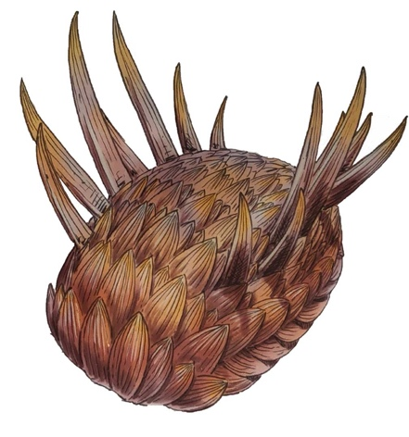
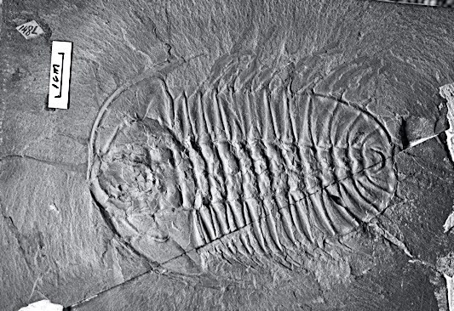

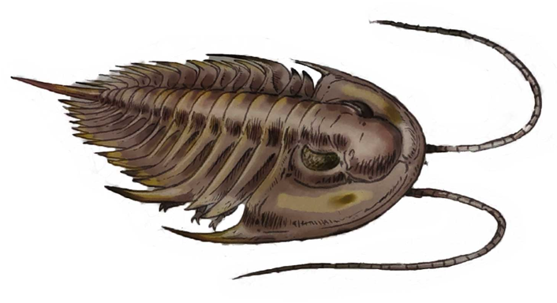
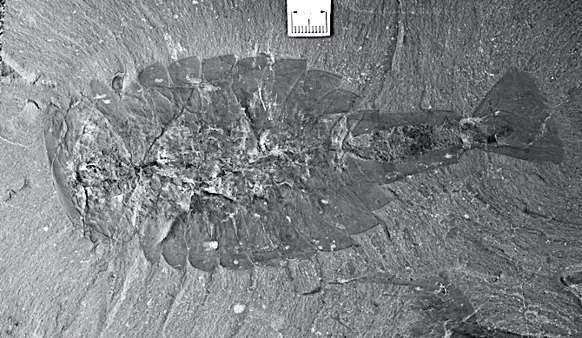

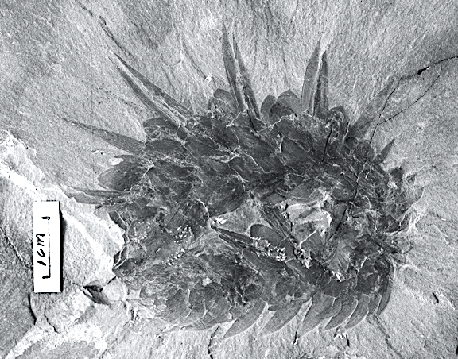

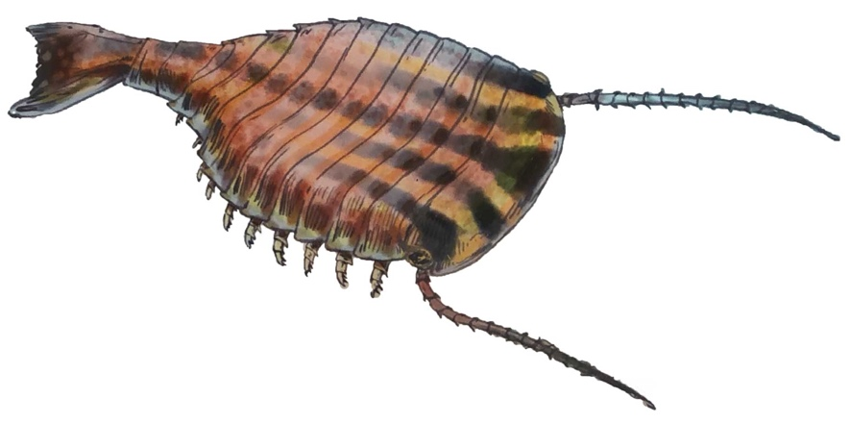

Imagining Ancient Animals: Scientists sketch what they discover to keep a record.

On the left is a scientist’s drawings of three different fossil animals. On the right is a fossil. Look closely at the fossil and the scientist’s drawings.
- Circle the scientist’s sketch that matches the fossil on the right.
- Use your pencil to outline the body parts on the image of the fossil.
Scientist’s Drawings Fossil
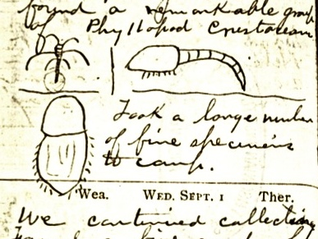
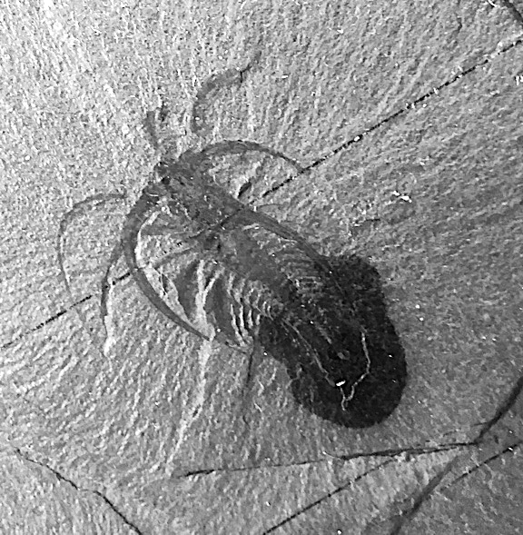

You be the scientist: Look closely at the fossil below and notice its features, like body shape and repeating patterns. Try drawing a simple sketch of the animal. If you’re not sure where to start, trace over the body parts on the fossil before you start your own sketch.

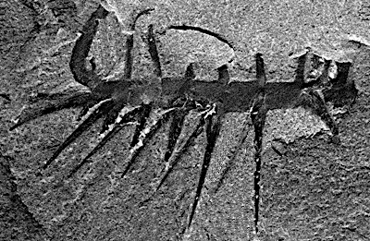

Make predictions: There are no wrong answers! Creativity is important while “reading” fossils.

- Are there any features that look familiar to you? Did you see any repeating shapes or patterns?
- Do you notice the sharp spines? What do you think they were used for?
- How do you think this animal moved?
Answer these questions or use them as a discussion guide after viewing the webcast.

- How can drawings of observations be useful?
- What new ideas do you have about how scientists “read” or interpret fossils?
- What might help scientists interpret fossils?
  - Microscopes to see them better
  - Drawing what they see
  - Comparing fossils to living animals
  - Comparing fossils to other fossils
- What was something you learned about the kind of work scientists do?
- What skills might be useful for scientists? Circle the ones you think work:
  - Making observations
  - Recording what they see
  - Working alone
  - Asking questions
  - Thinking they know everything
- List one thing scientists may be able to learn from ancient animal fossils.

