BIOREPOSITORY FIELD SAMPLING GUIDANCE
To ensure your samples arrive at the Biorepository in the best condition please review and follow the guidelines below. These steps will help to protect the integrity of samples and expedite inventory, scanning, and storage processes once the samples are received.

PRIOR TO GOING IN THE FIELD
- Obtain all required permits before collecting. Plan to collect only materials in your discipline, unless you have written permission from another department in advance. Consult with the Office of the Registrar if you have questions about permits.
- Request labels, preservatives and/or CryoShippers from the Biorepository Manager. Please give adequate advance warning (2 weeks or more for preservatives). CryoShippers cannot be transported on the MSC shuttle.
- The Biorepository does not provide cryovials for field collection. Please budget for cryovials as part of your field expenses.

IN THE FIELD
- If you are collecting animals or plants in the field, you should also collect tissues. Please fill tubes to the fill line, whenever feasible as those tissues may be very valuable/in high demand in the future. Collect multiple tubes of very rare organisms, if feasible.
- Use only Biorepository approved cryovials/containers for collecting. Approved containers: 2 ml and 8 ml cryovials, 0.5 ml and 1.0 ml Matrix tubes with screw-caps and 2.25” X 3.5” envelopes (Botany only).
  - Do not place loose Matrix tubes into CryoShippers. Matrix vials fill with liquid nitrogen and ultimately will be stored in a -80 freezers. If you want to store in LN, use 2 ml or 8 ml cryovials.
- Do not combine samples from multiple collecting departments in the same CryoShipper.
- Do not place samples lacking valid permits, etc. into the CryoShipper.
- Write Field Number (genus & species optional) on tube using #2 Pencil.
  - Sharpie or Cryo-Marker is acceptable unless the tube contains ethanol.
  - You may record the Biorepository Number on the tube as secondary means of preventing loss of information. Do not engrave it into the tube.
- Firmly affix Biorepository label to tube with barcode in VERTICAL position. Avoid obscuring hand written markings. The circle label can go in your field notebook, if you so desire. It does not need to be on the tube.
- Do not overload preservative (ethanol, DMSO, RNALater, etc.) with tissue.
  - One part tissue to 3 parts preservative is generally a good ratio.
  - RNALater: if using RNALater follow manufacturer guidelines for RNALater use. DO NOT freeze RNALater in liquid nitrogen. This can result in the tube exploding or cracking.
- Do not overfill vials. Leave headspace.
  - Respect 1.8ml fill line on 2mL vials.
- FIRMLY tightened cap to compress internal gasket.
- Wrap tubes with foil to prevent loss of Biorepository label or other exterior labels while floating/banging around in CryoShipper during collecting and transport.
- Do not place unlabeled tubes into CryoShipper.
- DO NOT USE CRYOSHIPPER AS A CHAIR.
- CryoShipper Sample Capacities:
10L CryoShipper (narrow mouth)
- 2mL vials - 450 tubes
- 8mL vials – 120 tubes
10L Large CryoShipper (Wide Mouth)
- 2mL – 700 tubes

IN TRANSIT
- Alert Biorepository staff before shipping with tracking numbers, etc.
- Avoid shipping tanks around Holidays and after Wednesday.
  - Alert Biorepository and departmental collections staff prior to sending return shipment.
- Ensure required permits are prepared prior to returning tank.
- Have IATA Exception Letter and exception codes for air transport. See example Air Bill and Letter below.
- Include unused tubes and labels with the returned CryoShipper. Do not use labels for other projects without consulting the Biorepository Manager.
UPON ARRIVAL
- Return CryoShipper to Biorepository as soon as possible.
- DO NOT leave CryoShipper containing samples more than 3 days without adding liquid nitrogen.

SAMPLE AIR BILL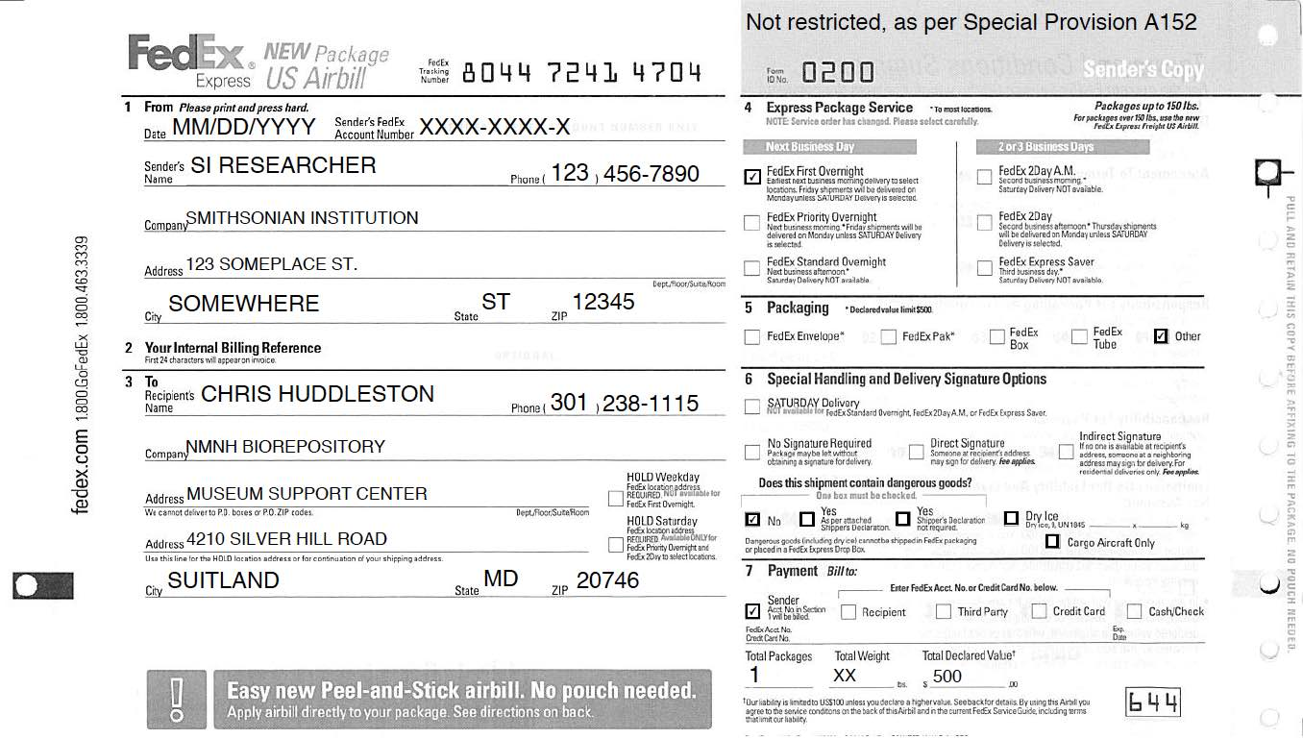

DEWAR DIMENSIONS (WITH SHIPPING CONTAINER)
Small
18” X 18” X 25” 26 lb. (uncharged), 31 lb. (charged with LN)
46 cm X 46 cm X 64 cm 12 kg (uncharged), 14 kg (charged with LN)

Large
22” X 22” X 27” 50 lb. (uncharged), 68 lb. (charged with LN)
56 cm X 56 cm X 69 cm 23 kg (uncharged), 31 kg (charged with LN)
LETTER EXPLAINING IATA EXCEPTION

This is concerning the applicability of the USA Federal Hazardous Material Regulations to the shipment of refrigerated samples in the “Dry Shipper” container. A “Dry Shipper” package consists of an outer container that is lined with an absorbent material. The container is charged with nitrogen refrigerated liquid which is absorbed into the container lining. The charged, completed package serves as a refrigerated container for the shipment of samples.

In consideration of the above, consultation with the Research and Special Programs Administration of the DOT has determined that the use of nitrogen refrigerated liquid charged “dry shipper” containers for the shipment of samples fall within the regulation exception provided in 49CFR 173.320 paragraph (a) of the section states the requirement of this subchapter do not apply to atmospheric gases and helium when used in the operation of the process system such as refrigeration system. For exception status of air shipments please refer to IATA-Dangerous Goods Regulations for nitrogen refrigerated liquid. This falls in the class of 2.2 nonflammable gas, packing instructions 202 with special provisions A-152. If shipping outside of the USA, please consult your applicable regulatory agencies. For answers to questions regarding shipping regulations contact a Chart, AI-Cryobiological Tech Service Representative.

