Making a Plant Specimen Dryer
Provided by Carol L. Kelloff

Materials needed:

Plant press frame:
4 lengths of 1-1/2" x 72" angled slotted zinc
16 - 1" bolts (3/8” diam. or size corresponding to holes in zinc)
16 - wing nuts
3 yards of canvas ca. 24" width or 1.5 yards of canvas if 48" in width
8 - 1" brass grommets

Electric Lamps for heat:
8" x 24" board
2 - 150 watt flood lamps
2 - lamp sockets
4 - wood screws
10 feet of 16/3 power cord with plug

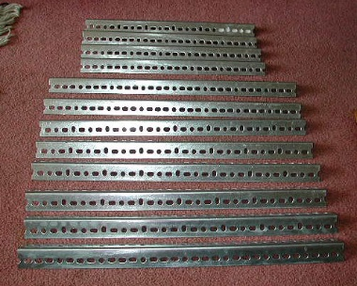
- Cut the zinc into 4 pieces 18-3/4" in length and 8 pieces 24" in length (Remember to cut the zinc so that the holes line up.)
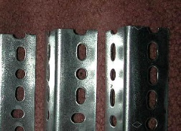

- Collect the 16-1" bolts and 16 wing nuts. Pick a diameter (probably 3/8") that is right for the holes in your Zinc frame.

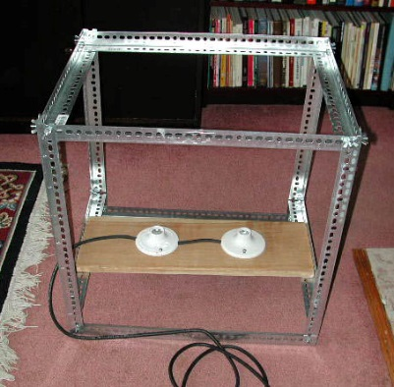
- Assemble the front and back framework of the dryer using four (4) 24" zinc per side. For the sides use the 18-3/4" pieces of zinc. Fasten the zinc at the corners using the bolts with the wing nuts facing out. Place the angle of the zinc with the open side facing in, ie: . This will provide a “shelf” for the plant press to rest on top and for the lamp board at the bottom.

The bottom zinc can be moved to adjust the height of the lamps.

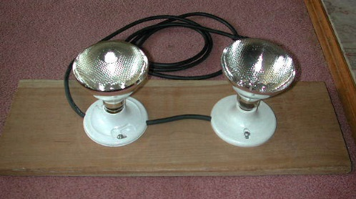
- Plant specimen dryer lights: Cut one piece 16/3 power cable 10 inches long. Strip off the ends to expose the wires. Connect the two lamp sockets (in series). Strip the bare end of the 16/3 power cord with plug to expose the wires and connect to one lamp socket. Screw the lamp sockets to 8" x 24" board approx. 6 - 8 inches apart.

- Cut the canvas 24" wide and approx. 88" in length. Fasten a brass grommet in the upper left corner of the canvas and attach using wing nut and bolt of frame. Stretch canvas to next corner, place grommet appropriately and attach to frame. Continue around frame until the canvas is completely attached to the frame. You may want to add a grommet to the bottom corners of canvas where the two ends meet. This will hold the canvas tight to the frame on the bottom.

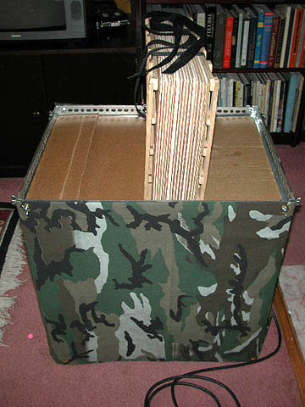
A standard plant press will sit on the lower angle of the zinc at the top of the dryer. Close off any space on either side of a thin plant press by using wooden board or cardboard. Tighten and flip the press daily or as needed. Drying time varies according to several factors including specimen characteristics, humidity, and air circulation. Check specimens after removed from the press to determine if dry.

CAUTION: FIRE HAZARD Check your plant drier frequently. Remember that you are dealing with paper and heat. Keep the heat source at a reasonable distance from the press. Make sure the press straps are not touching or hanging near the heat source.

Any heat source, incandescent or involving combustion, can be dangerous and neither the author nor Smithsonian take any responsibility for losses or injuries.
Use common sense!

